**Weekly #1 Show all work when needed!**

**Due on Friday, January 30, 2015**

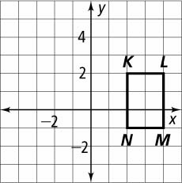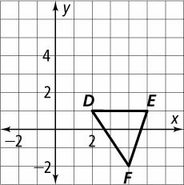**1.**  **2.** 

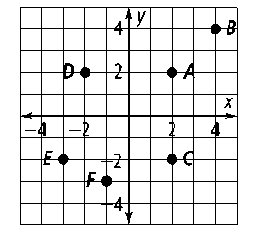**Each point is reflected across the line indicated. Find the coordinates of each image.**

**3.** *A* across the *x*-axis

**4.** *B* across the *y*-axis

**5.** *C* across *y* = x

**Coordinate Geometry Given points *M*(3, 3), *N*(5, 2), and *O*(4, 4), graph Δ*MNO* and its reflection image across each line.**

**6.** the *y*-axis **7.** the *x*-axis

**8.** *x =* 1 **9.** *y =* −2

**10.** **Δ***RST* has vertices at *R*(0, 3), *S*(4, 0), and *T*(0, 0). Find the coordinates of the vertices after a 90º clockwise rotation about *T.*

**11.** **Δ***FGH* has vertices *F*(−1, 2), *G*(0, 0), and *H*(3, −1). Find the coordinates of the vertices after a 90**°** counterclockwise rotation about *G.*

**Tell what type(s) of symmetry each figure has. If it has line symmetry, sketch the line(s) of symmetry. If it has rotational symmetry, tell the angle of rotation.**

**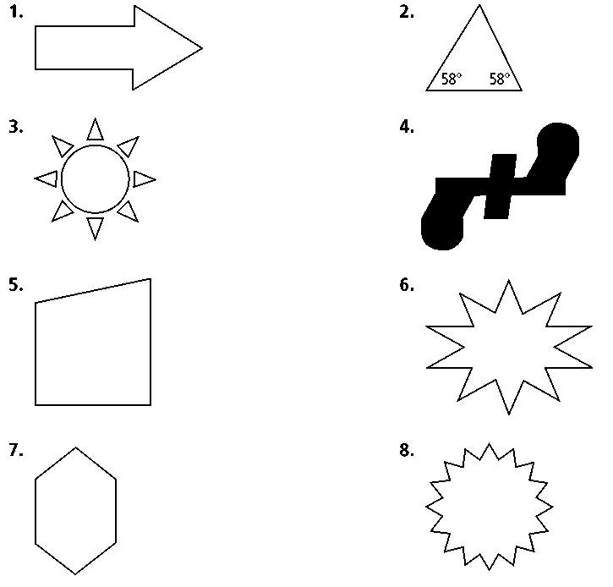****12. 13. 14.**



**Graph Δ*DML* and its glide reflection image for the given translation and glide reflection image reflection line.**

**17.** (*x, y*) → (*x*, *y* + 1); *x* = 2 **18.** (*x, y*) → (*x* + 3, *y* + 3); *y* = *x*

**15.** (*x, y*) → (*x* + 3, *y*); *x* = 0 **16.** (*x, y*) → (*x* − 1, *y*); *y* = 1

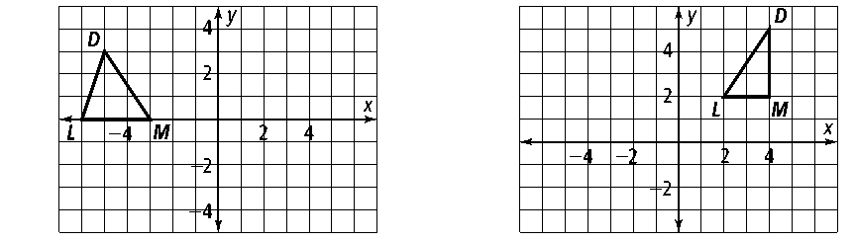

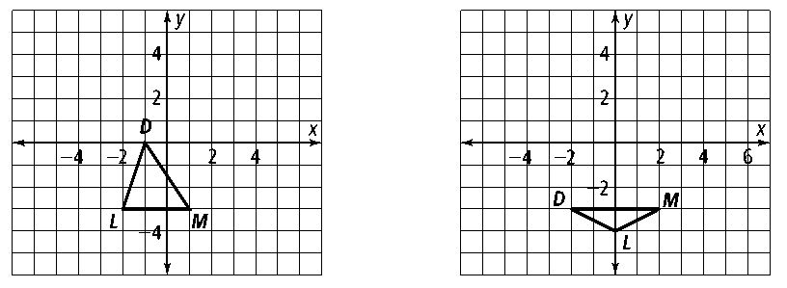

**19.** In which types of isometries are the image and preimage in the same orientation?

**20.** A triangle is reflected across line ℓ and then across line *m.* If this  
composition of reflections is a translation, what is true about *m*and ℓ*?*

**Graph and its image after a reflection across *ℓ*1 and then across *ℓ*2.**

**Is the resulting transformation a translation or a rotation? For a translation, describe the direction and distance. For a rotation, tell the center of rotation and the angle of rotation.**

**21.** *A*(−3, 4), *B*(−1, 0); **22.** *A*(−5, 2), *B*(−3, 6);

*ℓ*1 : *x* = 1; *ℓ*1 : *x* = −2;

*ℓ* 2 : *y* = −1 *ℓ*2 : *x* = 3

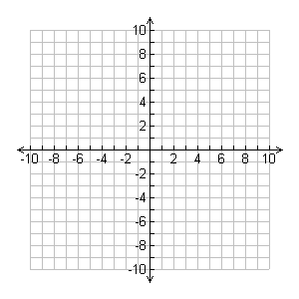

**A dilation has center (0, 0). Find the image of each point for the given scale factor.**

**23.** *D*(2, 2); 3 **24.** *M*(−3, 0); 2 **25.** *X*(2, −4); 0.25