Statistics: The Normal Curve and Standard Deviation
Mean | µ
Standard Deviation | σ

How to calculate standard deviation in the calculator:
Step 1: Enter data in List 1
Step 2: STAT -> CALC -> 1: 1-Var Stats
Step 3: 2nd L₁
Step 4: σ is the standard deviation

Find the mean and the standard deviation of the following data sets:
Teacher Example: prices of the first 10 cars sold at Joe’s Used Car Lot in 1998:
$900 $1300 $1200 $850 $800 $1250 $795 $950 $1020 $975

Prices of the first 10 cars sold at Joe’s Used Car Lot in 2008:
$2500 $2700 $3600 $5000 $1900 $6175 $4000 $7200 $9250 $3000

Student Example:
Times of boys in 100-m dash state high-school finals in 1998:
10.43 10.48 10.49 10.51 10.61 10.63 10.66 10.92

Times of boys in 100-m dash state high-school finals in 2008:
10.32 10.38 10.39 10.48 10.70 10.74 10.83 10.90

What does standard deviation mean?
The Normal Curve:
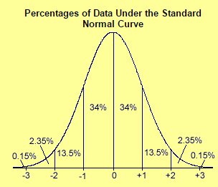
Example #1:
prices of the first 10 cars sold at Joe’s Used Car Lot in 1998:
$900 $1300 $1200 $850 $800 $1250 $795 $950 $1020 $975
Standard Deviation:

What is the range for 68% of the data?
95%?
99.7%?
Student Example:
Times of boys in 100-m dash state high-school finals in 1998:
10.43 10.48 10.49 10.51 10.61 10.63 10.66 10.92
Standard Deviation:

What is the range for 68% of the data?
95%?
99.7%?

- On the last history test, the average or mean was a 76 with a standard deviation of 3.
Draw the normal curve:

a. Your score was one standard deviation above the mean. What was your score?
b. Your friend in the class received a score 2 standard deviation below the mean, what was their score?

c. What percent of students scored a 73 – 79?

d. There were 31 students in the class. How many students scored a 70 – 82?

e. How many students scored a 73 – 82?

2. The last math quiz on logarithmic functions had a mean, µ, of 78 with a standard deviation, σ, of 7.5.
Draw the normal curve:

a. Your score was two standard deviations above the mean. What was your score?

b. Your friend’s score was one standard deviation below the mean. What was their score?
c. What percentage of students scored a 63 – 93?

d. There are 75 students in my three classes. How many students scored a 70.5 – 85.5?

e. How many students scored a 70.5 – 93?

Homework
Ex: Ms. Donoghue graded all of her Math 3 quizzes and found that they had a mean of 80 and a standard deviation of 4. She tells you that you earned a score of 1 standard deviation above the mean, but another student earned a score of 1 standard deviation below the mean. What are the 2 scores? | Ex: Idris averages 15 points a game in Vance basketball games, with a standard deviation of 2 points. If he had a great game and scored enough points to be 3 standard deviations above the mean, how many total points did he score?
Ex: On a Math 3 exam, the mean score was a 78 with a standard deviation of 5. Your score was 2 standard deviations above the mean. What was your score?  a) 86  b) 83  c) 88  d) 89 | Ex: You look up your favorite basketball player’s point average and find that a total of 28 points in a game is 1 standard deviation above the mean, while a total of 10 points is 2 standard deviations below the mean. What is the basketball player’s point average?  a) 20  b) 22  c) 18  d) 28
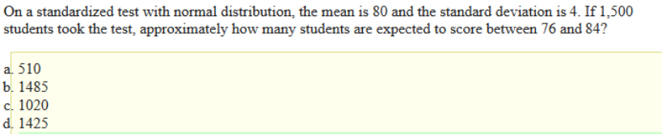
1.
2. 