Explicit Formula Geometric Series: $\left|r\right|>1$
$$S_{n}= \frac{a_{1}(1-r^{n})}{1-r}$$

$$a_{1}$$
r
n
$$s_{n}$$
Example 1: You want to set aside some money each year to save for a car. You save $200 each year in an account that yields 5.6%. How much money will you have in total after 5 years?

Example 2: In order to save some money you want to come up with a plan for saving. Option A involves saving $1000 each year in a mutual fund that yields an average of 4.5% per year for 20 years. Option B involves saving $500 each year for 30 years with the same 4.5% rate. Which option will yield the most money?

Example 3: Ms. Donoghue wants to plan early for her retirement. If she wants to have $100,000 when she retires. How much money will she need to save each year if she plans to retire in 30 years with a rate of 5.6%?

Example 4: (From the released exam)
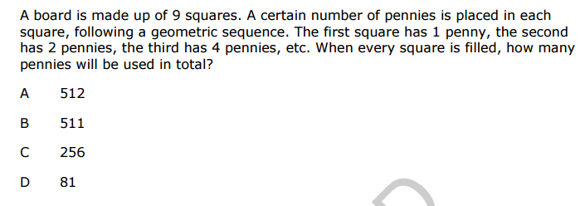

Explicit Formula Geometric Series: $\left|r\right|>1$
$$S_{n}= \frac{a_{1}(1-r^{n})}{1-r}$$

$$a_{1}$$
r
n
$$s_{n}$$
Example 1: You want to set aside some money each year to save for a car. You save $200 each year in an account that yields 5.6%. How much money will you have in total after 5 years?

Example 2: In order to save some money you want to come up with a plan for saving. Option A involves saving $1000 each year in a mutual fund that yields an average of 4.5% per year for 20 years. Option B involves saving $500 each year for 30 years with the same 4.5% rate. Which option will yield the most money?

Example 3: Ms. Donoghue wants to plan early for her retirement. If she wants to have $100,000 when she retires. How much money will she need to save each year if she plans to retire in 30 years with a rate of 5.6%?

Example 4: (From the released exam)

Geometric Series Practice Name: ___________________
- Danielle is planning to save up some money for a down payment on a car. She plans to save $100 for the next 4 years at a rate of 5.8%. How much money will she have in 4 years?

- Jason is saving money for an apartment after college. He plans to save $250 each year for the next 5 years. If he secures a rate of 4.35% how much money will he have in 5 years?

- Amanda is saving money for retirement. She plans to put aside $5000 per year for the next 30 years. How much money will she have if you invests in a mutual fund that yields a 6.8% interest rate?

- If you want to save $50,000 for a house. How much money would you need to put aside each year in order to have the $50,000 in ten years while investing in an account that has a rate of 3.5%

- A business profits $20,000 in its first year. Each year after the profit increased by an average of 10%. How much profit will the company make in total after 8 years?

- A table has a geometric design with triangles. The first row has 2 triangles, the second row has 6 triangles, and the third row has 18 triangles. How many total triangles are on the table if there are 12 rows in total?

- You win a lottery that offers to different pay out options. You have option A that is $1,000,000. Option B give you a penny on the first day, 2 pennies on the second day, 4 pennies on the third day and so on for 30 days. Which option would you take?

Geometric Series Practice Name: ___________________
- Danielle is planning to save up some money for a down payment on a car. She plans to save $100 for the next 4 years at a rate of 5.8%. How much money will she have in 4 years?

- Jason is saving money for an apartment after college. He plans to save $250 each year for the next 5 years. If he secures a rate of 4.35% how much money will he have in 5 years?

- Amanda is saving money for retirement. She plans to put aside $5000 per year for the next 30 years. How much money will she have if you invests in a mutual fund that yields a 6.8% interest rate?

- If you want to save $50,000 for a house. How much money would you need to put aside each year in order to have the $50,000 in ten years while investing in an account that has a rate of 3.5%

- A business profits $20,000 in its first year. Each year after the profit increased by an average of 10%. How much profit will the company make in total after 8 years?

- A table has a geometric design with triangles. The first row has 2 triangles, the second row has 6 triangles, and the third row has 18 triangles. How many total triangles are on the table if there are 12 rows in total?

- You win a lottery that offers to different pay out options. You have option A that is $1,000,000. Option B give you a penny on the first day, 2 pennies on the second day, 4 pennies on the third day and so on for 30 days. Which option would you take?

