ASSIGNMENT (Unit 5/ Day 3) Math III – Unit 1 Geometry
Day 3: Congruent Triangles

- Given ΔABC and ΔEDC with $\overline{AB}≅ \overline{EC}, \overline{BC}≅\overline{ED}, and <ABC ≅ <CED.$ What is the reason for ΔABC $≅$ ΔCED?

- State if the triangles are congruent. If they are, state how you know.
a) b)
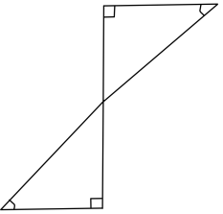

c) d)
- Write the congruence statement for each triangle.

- ΔMPN $≅$ Δ______ b) ΔDCE $≅$ Δ______

- Given ΔQRS and ΔUTV, with $\overline{QR}≅\overline{UT}, \overline{RS}≅\overline{TV}, and<RQS ≅ <TUV.$ Is
ΔQRS $≅$ ΔUTV? If so, state how you know.

