ASSIGNMENT (Unit 5/ Day 2) Name: _______________________
Unit 5 – Geometry Day 2 – Parallelograms
1) MOLD is a parallelogram.
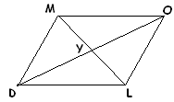

- If DM = 6x – 26 and LO = 3x + 10, find MD.
- If OY = 3x - 4 and DY = 2x + 2, find x.
- If <DMO = 55, find m<MOL.
- If <DMO = 55, find m<DLO.
2) PICK is a rhombus
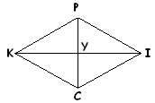
. a) If PC = 12 and KI = 16. Find the perimeter of PICK.
b) If <KPI = 46, find m<ICY.
3) BARK is a rectangle.
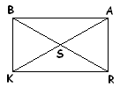
a) BS = 3x – 4 and AS = x + 12. Find KA .
b) What is the measure of <KBA?

4) You want to paint a wall that is in the shape of a rhombus. The wall has diagonals that are 7 meters and 12 meters. Deelux Matt Emulsion paint costs $8.50 per meter square. How much will it cost to paint this rhombus-shaped wall?

