ASSIGNMENT (Unit 4/ Day 1) Math III – Unit 2
Day 1: Angles of Circles
- In a recent poll, 600 people were asked whether they liked Chinese food. A circle graph was constructed to show the results. The central angles for two of the three sectors are shown in the accompanying diagram. How many people had no opinion?
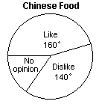
- In the diagram of circle O, the measure of arc is 64°. What is m∠RTS?
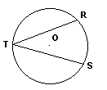
- In the diagram of circle O, m∠ABC = 38. What is m∠AOC?
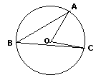
- In the diagram, isosceles triangle ABC is inscribed in circle O and m∠BAC = 40. Find the measure of arc .
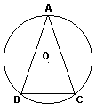

- In the diagram of circle O, is tangent to O at Q and is a secant. If m∠P = 56 and m = 192, find m.

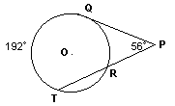
- In the diagram of circle O, m = 64 and m∠AEB = 52. What is the measure of ?

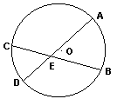
- In the diagram of circle O, chord is parallel to chord . If m = 100, find m∠BOD.
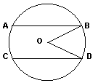
- In the diagram of circle O, the ratio of to is 2:1. What is m∠ACB? 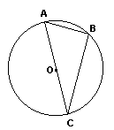

- In a circle, an inscribed angle intercepts an arc whose measure is (14x − 2)°. Express, in terms of x, the number of degrees in the measure of the inscribed angle.

