ASSIGNMENT (Unit 2 / Day 8) Math III – Unit 2 Circles & Parabolas
Day 8: Equation of a Circle

1) Write an equation for a circle with center (-3, 1) and radius 8.

2) write the equation of the circle $x^{2}+8x+ y^{2}+6x=5$

3) If (x − 3)² + (y + 5)² = 9 is the equation of a circle, what are the coordinates of the center and the length of the radius.

4) What equation represents the circle shown in the graph?
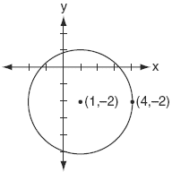

5) Write the equation of the circle for $x^{2}+10x+y^{2}+14x=34$

6) Write the equation that represents the circle shown in the graph.
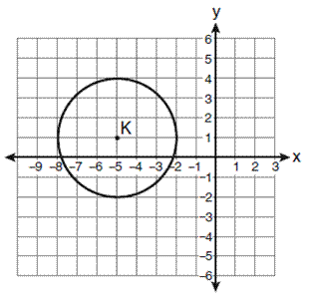

7) The endpoints of a diameter of a circle are (-7, 11) and (9,-3). What is the equation of the circle?

