ASSIGNMENT (Unit 2 / Day 2) Math III Unit 2
Angles & Tangents of Circles
- Find the values of a, b, and c. | - Find x.  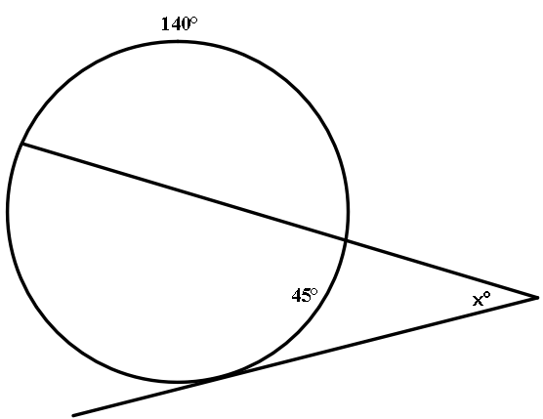
- Find x. |  | - In the figure below, $\overline{PR }$and $\overline{SR }$are tangent to circle O. If OT = 12 cm and PR = 65 cm, what is the length of $\overline{OR}$?  