Geometry Unit 2 Study Guide - Transformations
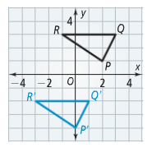
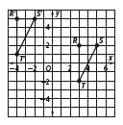
- In the graph at right, ∆R’Q’P’ is a translation image of ∆RQP.
Write the rule for this translation.

- Which of the following are isometries? EXPLAIN WHY: Translation, Reflection, Dilation, Rotation
For 3-6, write the NEW coordinates for the image of ABC for each transformation.
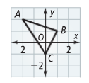
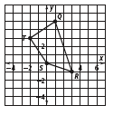
3. reflection across the x-axis
4. rotation of 90° clockwise about the origin
5. dilation with center (0, 0) and scale factor 3
6. reflected across the y-axis

7. What is the image of point C(4, -3) after a reflection across the y-axis?

For questions 8-9, state whether each transformation is a reflection, rotation, translation, or dilation.
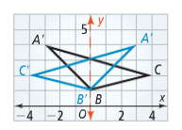
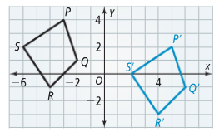
8. 9.

For questions 10 - 15, refer to the figure at the right.
10. What is the image of F under 11. What rule describes
(x, y) → (x -2, y +0)? the translation B → F?
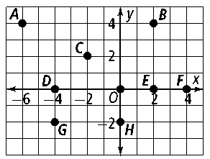
12. What is the image of C under 13. What rule describes
(x, y) → (x − 2, y - 2)? the translation D → A?
14. What is the image of G under 15. What rule describes
(x, y) → (x +8, y +2)? the translation B → C?
Write the coordinates for A’, B’, and C’ under the given transformation.
16. ΔABC with vertices A(-2, 5), B(0, -1), C(2, 6); dilated by a factor of ½
17. ΔABC with vertices A(1, 4), B(7, 0), C(5, 3); rotated clockwise 270°
18. ΔABC with vertices A(−8, −3), B(−4, 2), C(3, 9); reflected across the line $y=-x$
19. Segment BC with endpoints B (4, 9) and C (2, -1) is rotated, and it becomes segment P’Q’ with endpoints B’ (-9, 4) and C’ (1, 2). How much was it rotated in a clockwise direction?
20. ΔABC with vertices A (1, 5), B (4, 2), and C (5, 5) is rotated 180°. Graph ΔABC and ΔA’B’C’.
