Factoring Practice- Side 1 Name: _______________________
Factor the following trinomials:
- x² + 7x + 12

- x² – 4x – 32

- x² - 18x + 80

- x² – 2x – 35

- x² – x – 110

Factor the following: (hint: difference of squares)
- x² – 16

- 4x² – 81

- 9x² – 144

Mixed Practice: Factor the following
- x² – x – 56

- 4x² – 49

- 16x⁴ – 121

- (x - 4) and (x + 12) are the factors of the polynomial p(x). What is the polynomial p(x)?
Factor by Grouping Practice – Side 2:
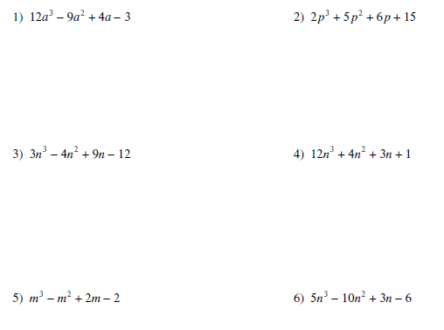

Exit Ticket:

