HONORS: LAW OF SINES & LAW OF COSINES

If you DO NOT have a right triangle, you can still find missing measurements using TRIGONOMETRY!!!
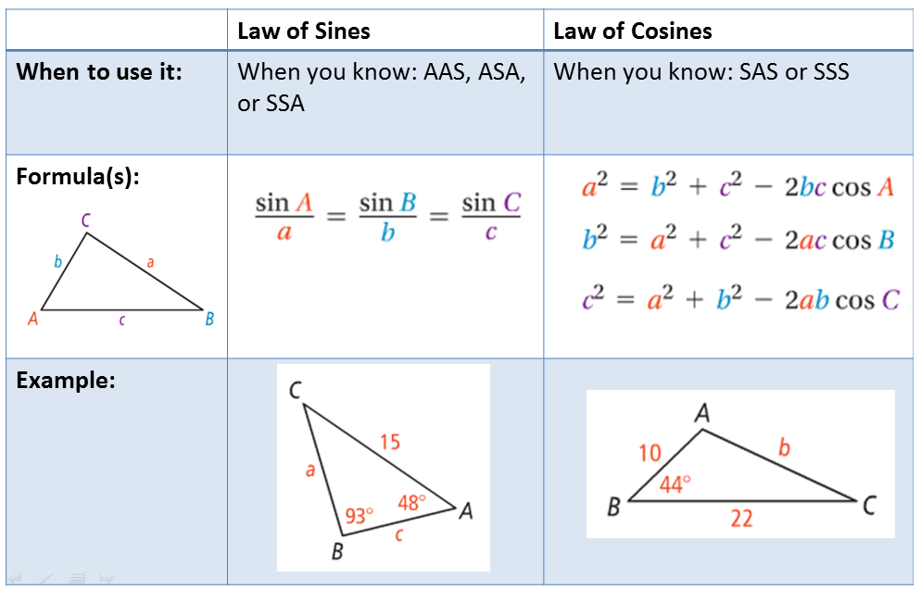

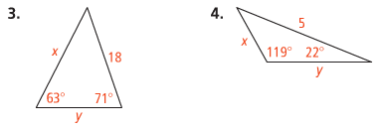
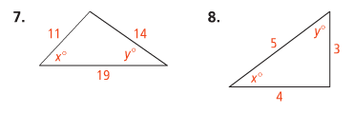
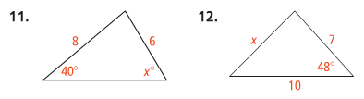
HONORS: LAW OF SINES & LAW OF COSINES

If you DO NOT have a right triangle, you can still find missing measurements using TRIGONOMETRY!!!

