Homework Week #14 Name: ________________________
“In order to succeed, we must first believe that we can!” –Nikos Kazantzakis
- Find the inverse of the following function:
$$f(x)=x^{2}+7$$

- Find the inverse of the following function:
$$y= 3x+2$$

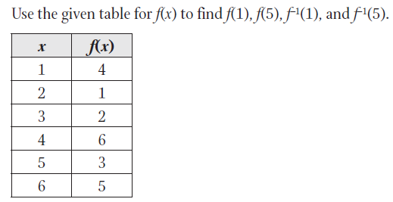

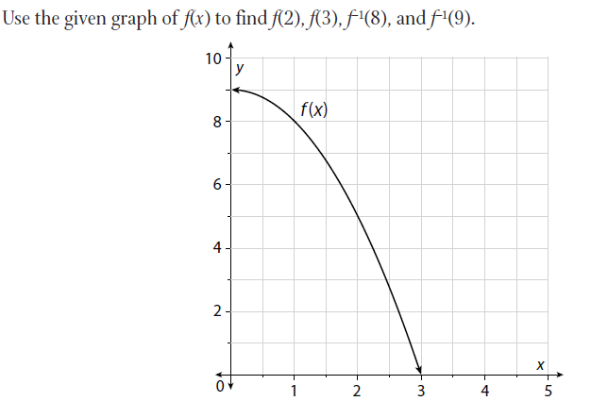

Solve the following:
$\frac{2}{x-3}-\frac{4}{x+4}$ | $$\frac{3x}{x^{2}-9}+ \frac{4}{x-3}$$
$$\frac{3x}{(x+3)}-\frac{ 7x}{(x+5)}$$ | $\frac{2x+8}{x^{2}-16}-\frac{3}{x-4}$
$$\frac{x^{2}-x-2}{x^{2}+2x+1} ÷ \frac{x^{2}-8x+12}{x+1}$$ | $$\frac{(x^{2}+7x+12)}{(x+4)}×\frac{(x+5)}{x^{2}-25}$$

Identify the center and the radius of the following circles:
- x² + 8x + y² + 6y = 0

- x² + 12x + y² – 10y = 12

- x² + 12x + y² + 4y = 5

Log Review:
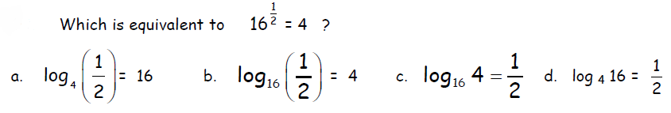
1.

2.

3.

Solve for x.
4. $\log_{7}{64- \log_{7}{x^{2}=log_{7}}}$4

Convert from logarithmic form to exponential form.
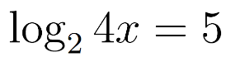
5.

Solve for x.
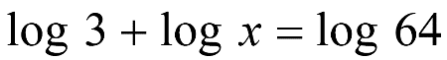
6.

Solve for x.
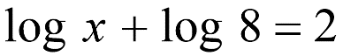
7.

