Homework Week #12 Name: ____________________
“Don’t worry about failures, worry about the chances you miss when you don’t even try.” –Jack Canfield
Monday: Equation of a Circle Practice: Find the center and the radius of each of the following circles.
- x² + 8x + y² + 6y = 0

- x² + 12x + y² – 10y = 12

- x² + 4y + 6x - 10 = -y²

- x² + y² + 14x + 16y = 0

- x² + 12x + y² + 4y = 5

Tuesday:
- $\frac{5}{x}+ \frac{3}{5}$

- $\frac{4}{5}-\frac{5}{x+2}$

- $\frac{2}{x+3}+\frac{5}{x-2}$

- $\frac{3x+7}{x^{2}-9}-\frac{3}{x-3}$

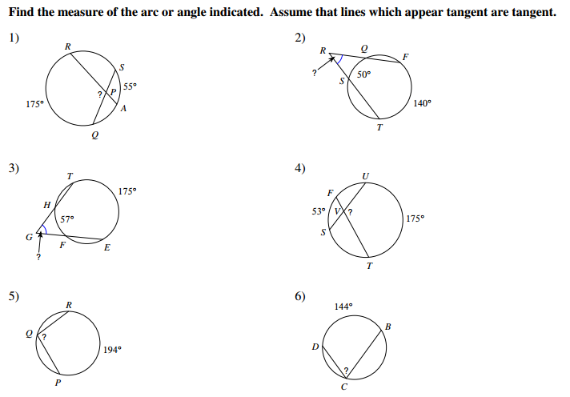
Wednesday:

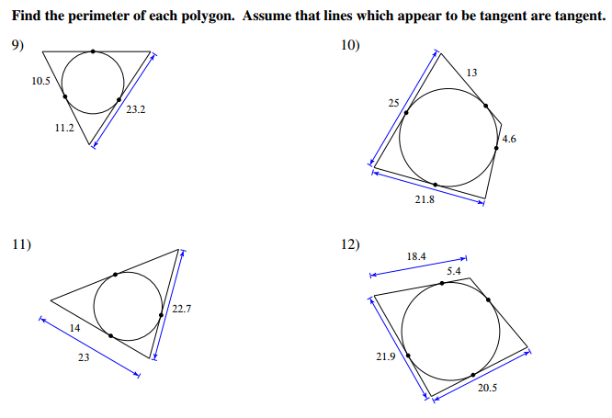
Thursday:

