Homework Week 11 – Due on Friday Name: ___________________
“To me perseverance is having the will to be able to keep pushing forward” – J-von Hudson
- Divide the following using synthetic division:
$$({6x}^{3}-7x^{2}-17x-14)÷(x-2)$$

- Divide the following using synthetic division:
$$(x^{3}+5x^{2}-9)÷(x+2)$$

- Divide the following using synthetic division:
$$({2x}^{4}+5x^{2}-8)÷(x+1)$$

- Divide the following using your method of choice:
$$({5x}^{3}-7x^{2}-18x-14)÷(x-2)$$

Tuesday: Simplify the following: (use Pythagorean identities)
- secx – tanx sinx

- tanx + cotx

- cosx + tanx sinx

- 1 + tan²x

- secx – cosx

Wednesday:
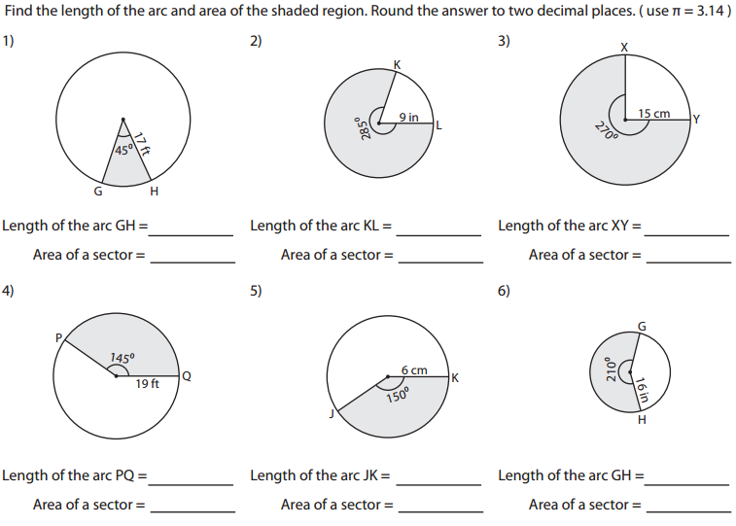
Thursday: (Mixed Review)
1.
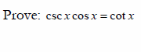
2. Identify sin 225º

3. Identify the amplitude and the period of the following:
Y = 4sin2x

4. Identify the center and the radius of the following circle:
X² + y² + 18x + 15 = 12y

5. Identify the center and the radius of the following circle:
X² + y² + 4x - 5 = 8y

