Homework Week 10 – Due on Thursday Name: ___________________
“Even the word impossible has possible in it” – Reshawn Cook
Monday: $Identify the following using the unit circle.$

Cos $\frac{2π}{3}$

Sin 150º

Sin $\frac{π}{3}$

Cos $\frac{5π}{3}$
Simplify the following

- $\frac{cotx}{cscx}$

- tanx cosx

- $\frac{sinx}{cotx}$

- sinx + cotx

Tuesday:
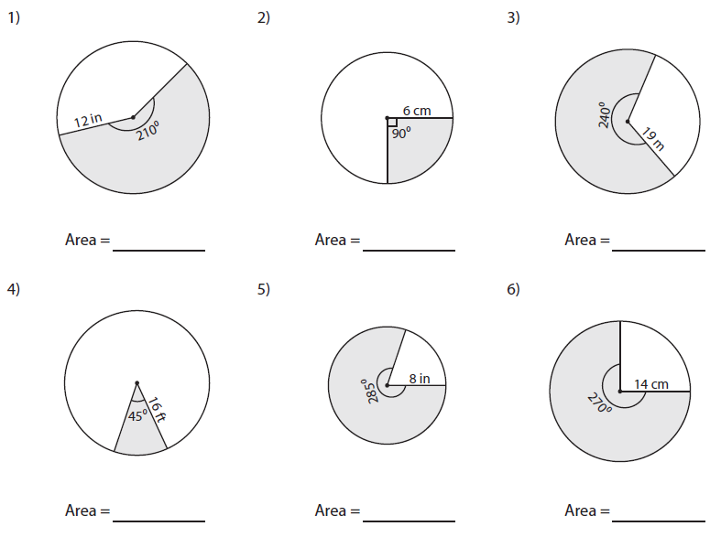

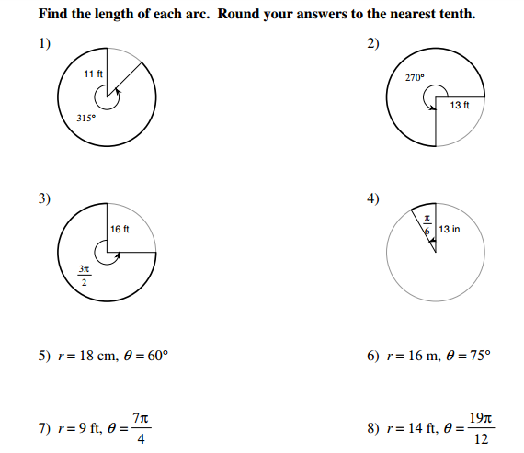
Wednesday:

