Math 3 Unit 1 - Factoring
x² – 8x – 48 | 25x⁴ – 4y⁴  (hint: this is a difference of squares) | 3x³ + 9x² + 2x + 6
2x² – 162  (hint: factor out a GCF) | 2y² – 9y – 5 | 18x² – 9x  (hint: factor out a GCF )
2x² - 8x – 10 | 2x³ + 8x² + x + 4 | 4x² – 81  (hint: this is a difference of squares)
3x² + 8x + 4 | x⁴ – 1  (hint: this is a difference of squares) | 9x³ + 12x² – 3x – 4
Challenge: 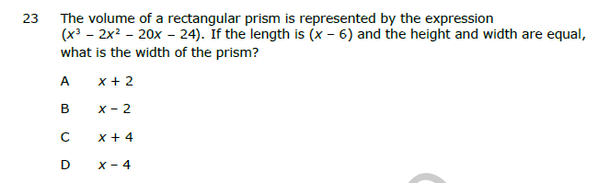
Show that (x + 3) is a factor of (x³ + 7x² + 16x + 12) and determine the other two factors.

