Unit 3 Math III Honors
Trig Graphs
- A student attaches one end of a rope to a wall at a fixed point 3 feet above the ground, as shown in the accompanying diagram, and moves the other end of the rope up and down, producing a wave described by the equation y = a sin bx + c. The range of the rope’s height above the ground is between 1 and 5 feet. The period of the wave is 4π. Write the equation that represents this wave.
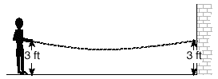
- The brightness of the star MIRA over time is given by the equation $y=2sin\frac{π}{4}x+6$ where x represents time and y represents brightness. What is the period of this function, in radian measure?

- A certain radio wave travels in a path represented by the equation $y=5sin2x$. What is the period of this wave?

- The path traveled by a roller coaster is modeled by the equation $y=27sin13x+10$. What is the maximum altitude of the roller coaster?

- An object that weighs 2 pounds is suspended in a liquid. When the object is depressed 3 feet from its equilibrium point, it will oscillate according to the formula x = 3 cos (8t), where t is the number of seconds after the object is released. How many seconds are in the period of oscillation?
- The accompanying diagram shows a section of a sound wave as displayed on an oscilloscope. Write the equation.
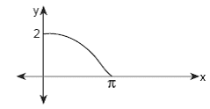
- In physics class, Eva noticed the pattern shown in the accompanying diagram on an oscilloscope. Write the equation.
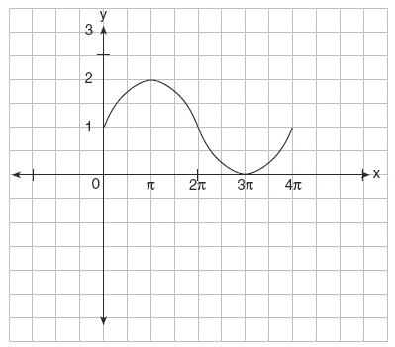
- A radio transmitter sends a radio wave from the top of a 50-foot tower. The wave is represented by the accompanying graph. What is the equation of this radio wave?
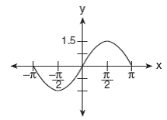
- What is the maximum value for the function $y=\frac{1}{3}sin5x?$
- What is the phase shift of the following equation?
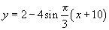
Sketch each of the trigonometric functions. State the domain, range and period.
- f(x) = cos(x)

- f(x) = sin(x)

